Haralds plan efter kraschen 14 maj 1928 vid Klippan
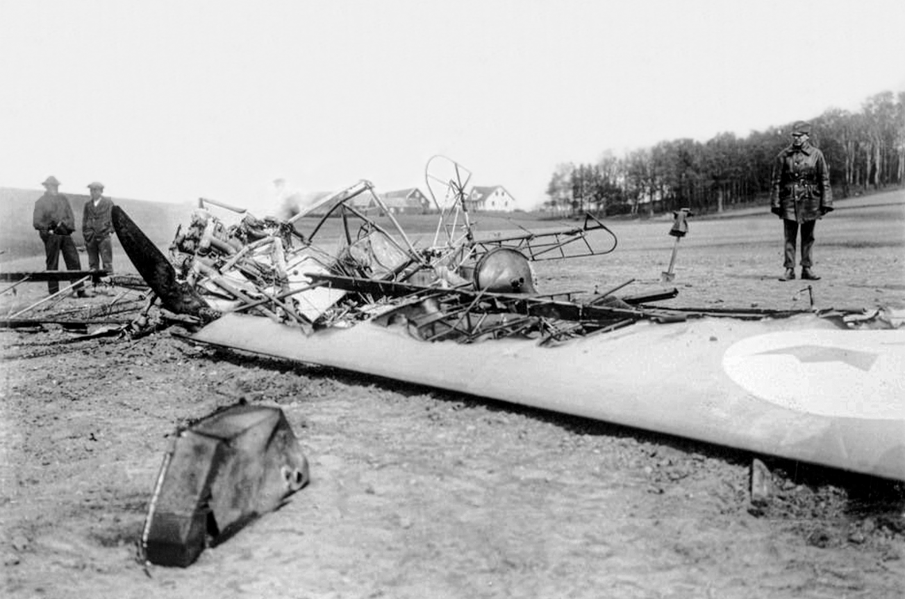
Till höger en militär. De två personerna till vänster kan vara från gården vars fält han kraschade på.

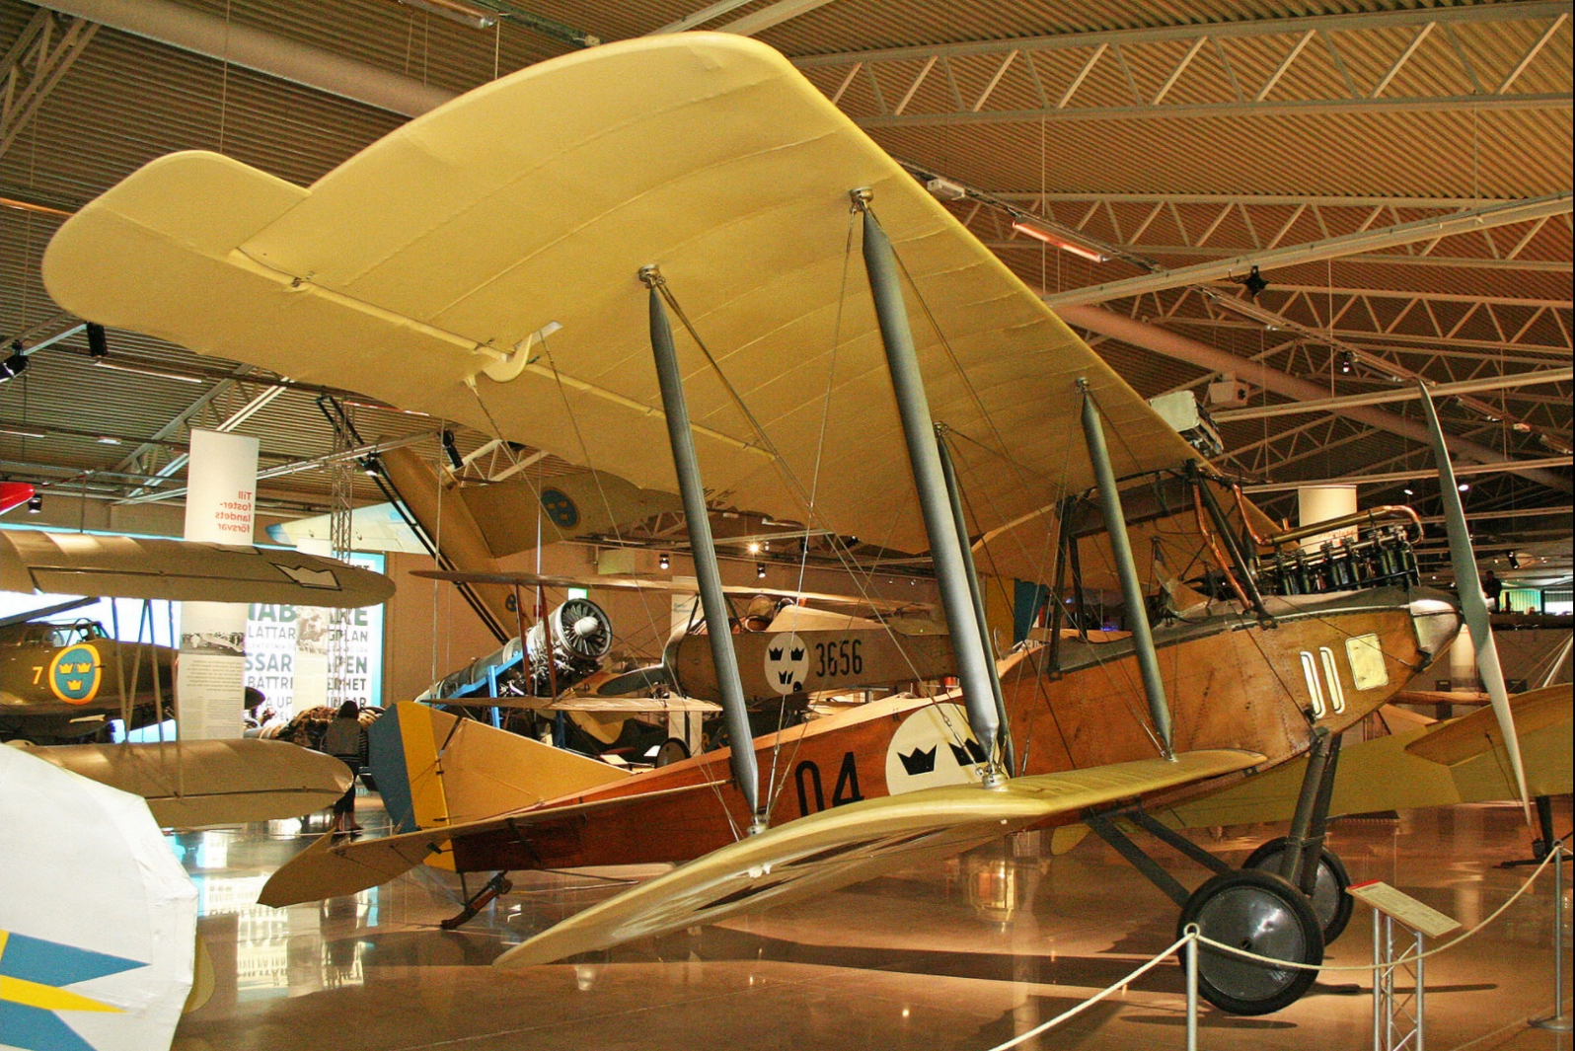

Vad kan gården i bakgrunden heta och finns den kvar?
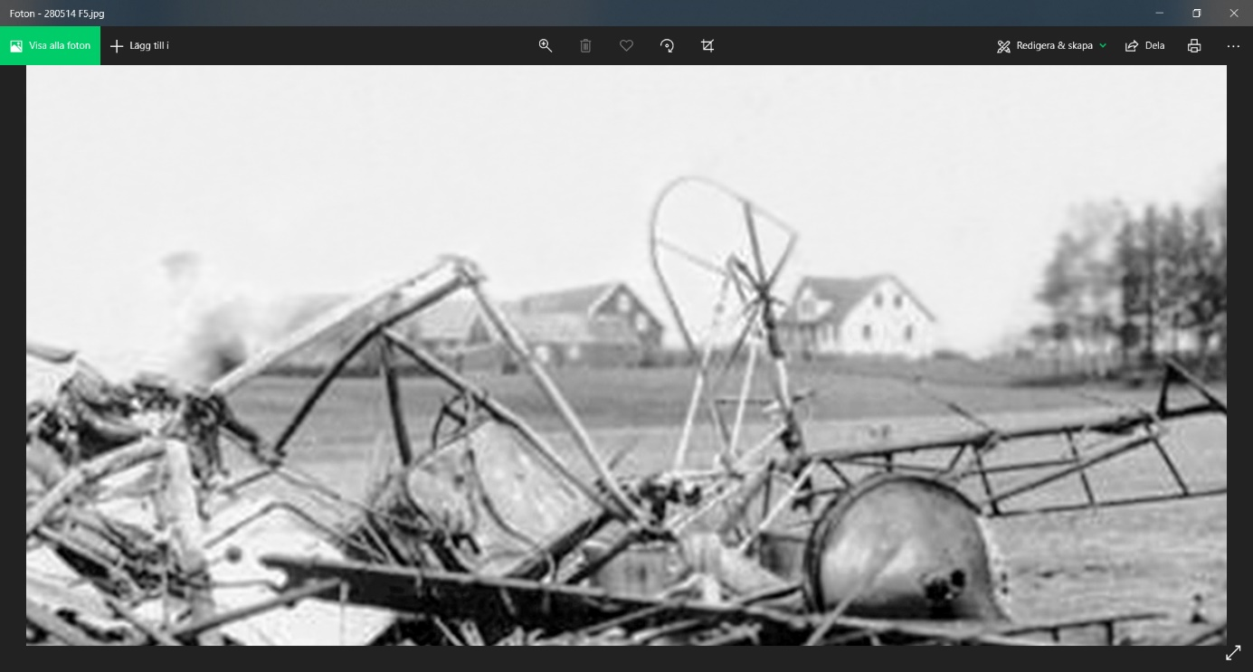

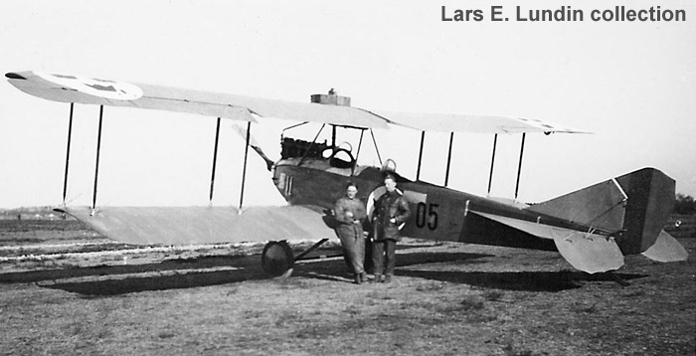
At the outbreak of the WWI a German Albatros B.IIa - damaged after a forced landing in Stockholm - was kept and later bought by the Swedish authorities. The Albatros was used as a pattern for manufacturing in Sweden. Totally 42 aircraft of this type were operated by the early army aviation.
Also the navy aviation used the Albatros B.IIa, but these five aircraft were bought (in second-hand) from Germany.
When the Air Force was established in 1926, the following Albatros aircraft were taken over by the new service branch:
- Five Albatos B.II aircraft with 120 hp Mercedes engines (”120-trossar”) from the Army Aviation Company. All built by the workshops of the Army Aviation Company at Malmen (FVM = Flygkompaniets Tygverkstäder på Malmen). Air Force designation Sk 1.
- Three Albatros B.IIa aircraft with 120 hp Mecedes engines from the Navy. All of German origin. Air Force designation Sk 1.
- Ten Albatos B.II aircraft with 160 hp Mercedes engines (”160-trossar”) from the Army Aviation Company. All built by the workshops of the Army Aviation Company (FVM). Because of its stronger engines, these aircraft were designated as advanced trainers. See Ö 2 - Albatros B.II!
The aircraft were handed over to and used by the new Air Force Flight Academy at Ljungbyhed (F 5).
Engine trouble was constantly a problem for the Sk 1. Due to this, three aircraft were written off in 1928. A grounding order for the remaining five was issued in 1929. The aircraft were written off the same year.
Photo at top shows Sk 1 "05" in old days. Photo below of No. 2136.
The photo at bottom shows one of the youngest Albatros B.II. This aircraft is preserved at Flygvapenmuseum (the Swedish Air Force Museum) at Malmen close to Linköping. It carries the marking ”04” and was built at Malmen in 1925. It is one of the Sk 1s that were written off in 1929. C/n 464.
Length: 7,8 m. Span: 13,1 m. MTOW: 1.135 kg. Max. speed: 116 km/h.
